20BDS0146

VENNELA G

PROGRAMMING FOR DATA SCIENCE

LAB ASSESSMENT-1

**Question 1**

print("Hello World")

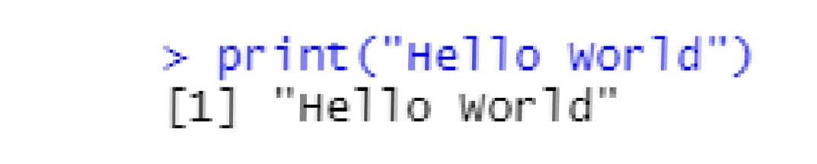

**Question 2**

a=as.integer(readline(prompt="Enter a number"))

print(a)

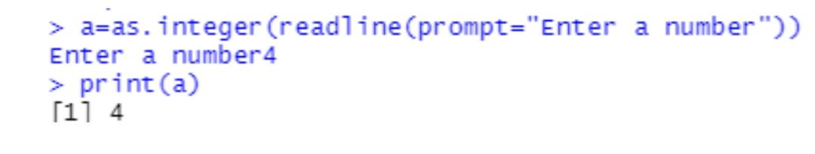

**Question 3**

b=as.integer(readline(prompt="Enter a number"))

c=as.integer(readline(prompt="Enter a number"))

d=as.integer(readline(prompt="Enter a number"))

e=as.integer(readline(prompt="Enter a number"))

v1=c(b,c)

v2=c(d,e)

v1+v2

v1-v2

v1*v2

v1/v2

v1%%v2

v1%/%v2

v1^v2

v1>v2

v1<v2

v1<=v2

v1>=v2

v1==v2

v1!=v2

v1&v2

v1|v2

!v1

v1&&v2

v1||v2

y<-8

y

1->z

z

print(b:a)

v1%*%v2

v1%in%v2

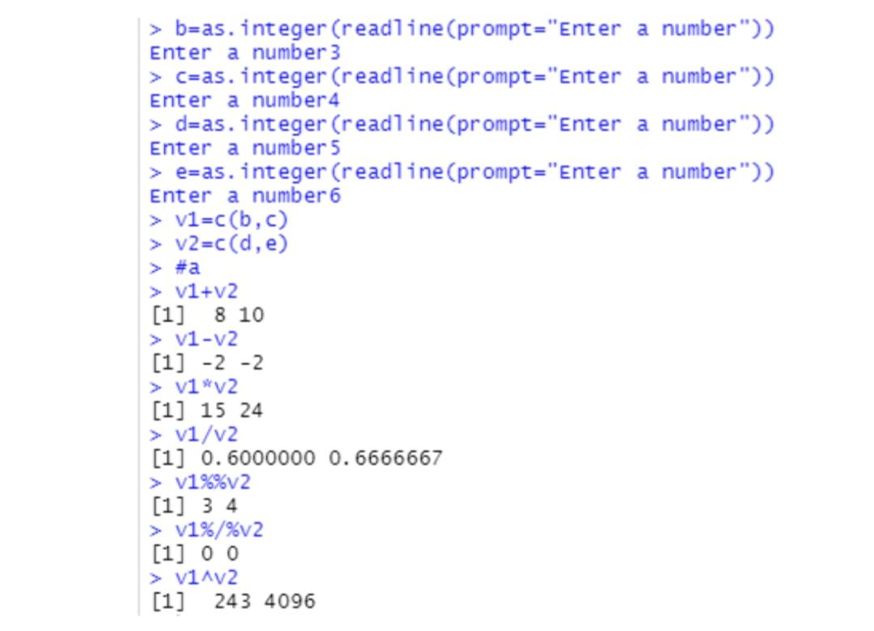

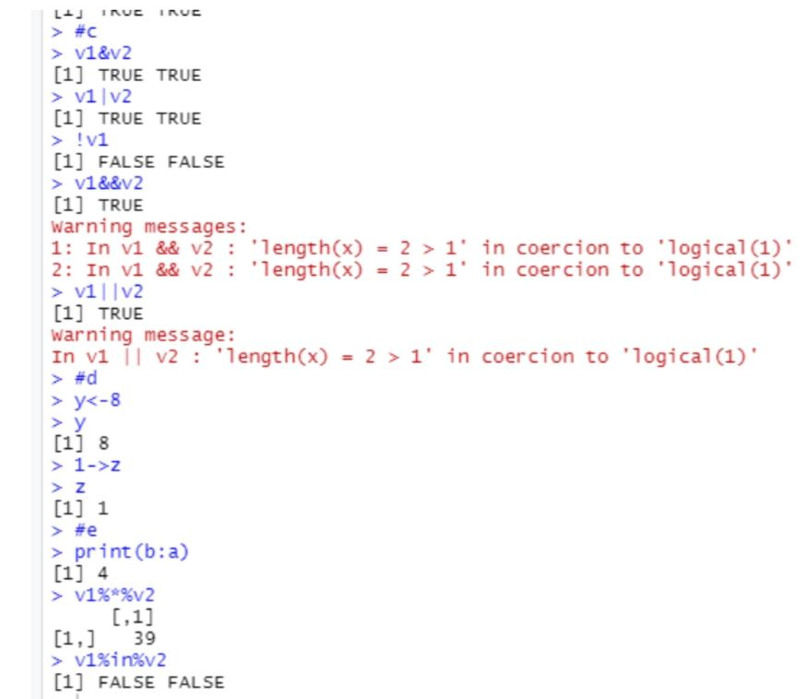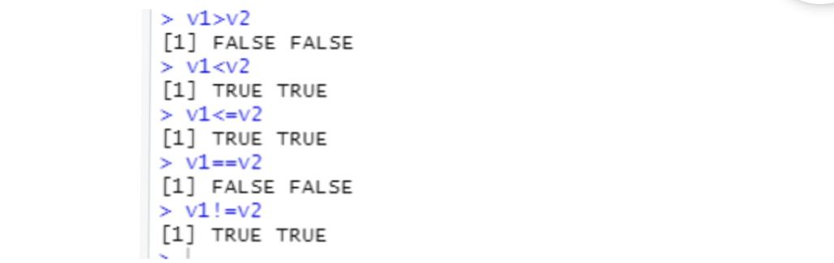

**Question 4**

num = as.integer(readline(prompt="Enter a number: "))

if((num %% 2) == 0) {

print(paste(num,"is Even number"))

} else {

print(paste(num,"is Odd number"))

}

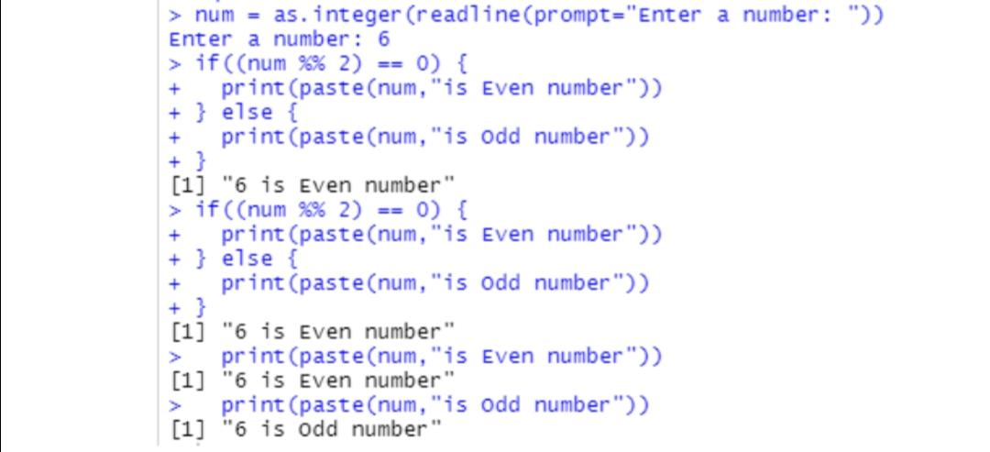

**Question5**

mark=as.integer(readline(prompt="Enter the student mark:"))

if(mark>=90){

print(paste("S Grade"))

}else if(mark>=80 && mark<90){

print(paste("A Grade"))

}else if(mark>=70 && mark<80){

print(paste("B Grade"))

}else if(mark>60 && mark<70){

print(paste("C Grade"))

}

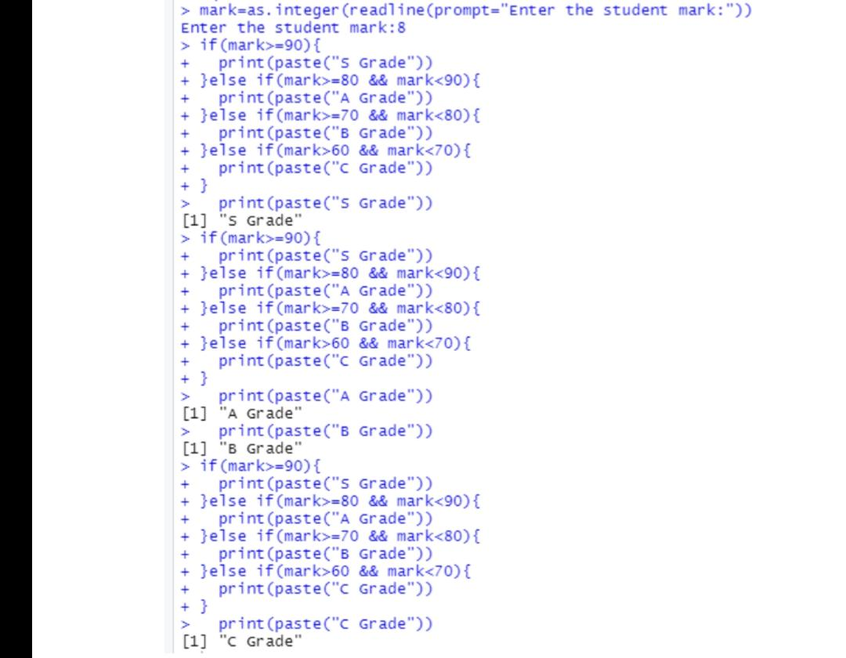

**Question6**

add <- function(x, y) {

return(x + y)

}

subtract <- function(x, y) {

return(x - y)

}

multiply <- function(x, y) {

return(x * y)

}

divide <- function(x, y) {

return(x / y)

}

print("Select operation.")

print("1.Add")

print("2.Subtract")

print("3.Multiply")

print("4.Divide")

choice = as.integer(readline(prompt="Enter choice[1/2/3/4]: "))

num1 = as.integer(readline(prompt="Enter first number: "))

num2 = as.integer(readline(prompt="Enter second number: "))

operator <- switch(choice,"+","-","*","/")

result <- switch(choice, add(num1, num2), subtract(num1, num2), multiply(num1, num2), divide(num1, num2))

print(paste(num1, operator, num2, "=", result))

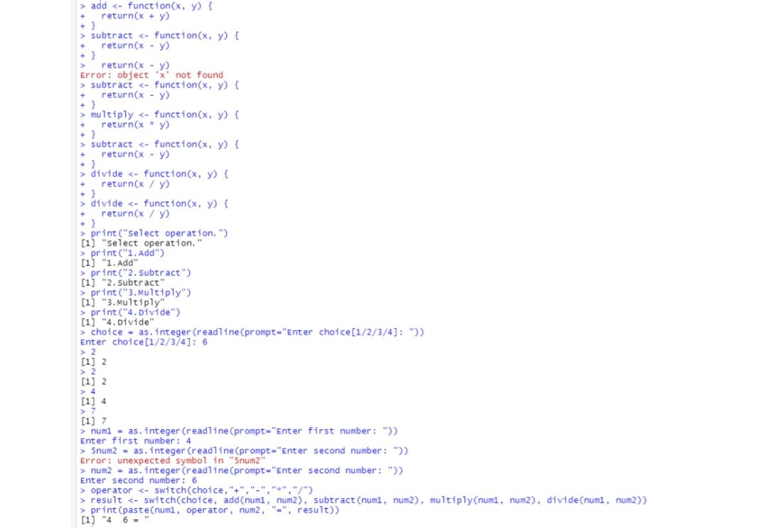

**Question7**

num = as.integer(readline(prompt="Enter a number: "))

factorial = 1

if(num < 0) {

print("Sorry, factorial does not exist for negative numbers")

} else if(num == 0) {

print("The factorial of 0 is 1")

} else {

for(i in 1:num) {

factorial = factorial * i

}

print(paste("The factorial of", num ,"is",factorial))

}

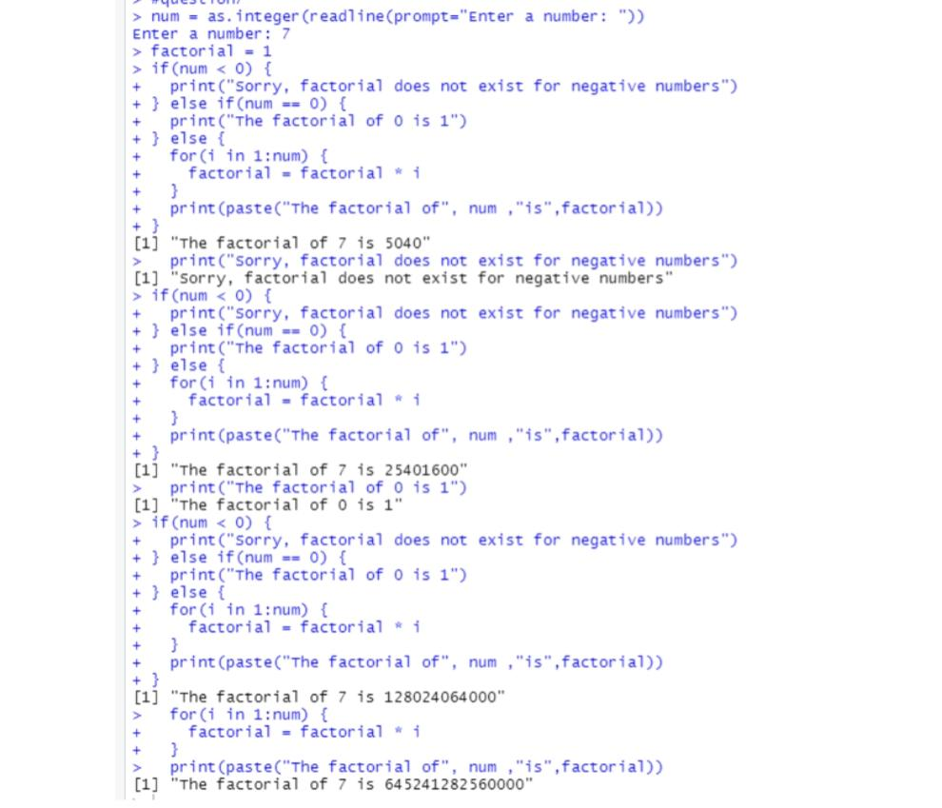

**Question 8**

num = as.integer(readline(prompt="Enter a number: "))

sum = 0

temp = num

while(temp > 0) {

digit = temp %% 10

sum = sum + (digit ^ 3)

temp = floor(temp / 10)

}

if(num == sum) {

print(paste(num, "is an Armstrong number"))

} else {

print(paste(num, "is not an Armstrong number"))}

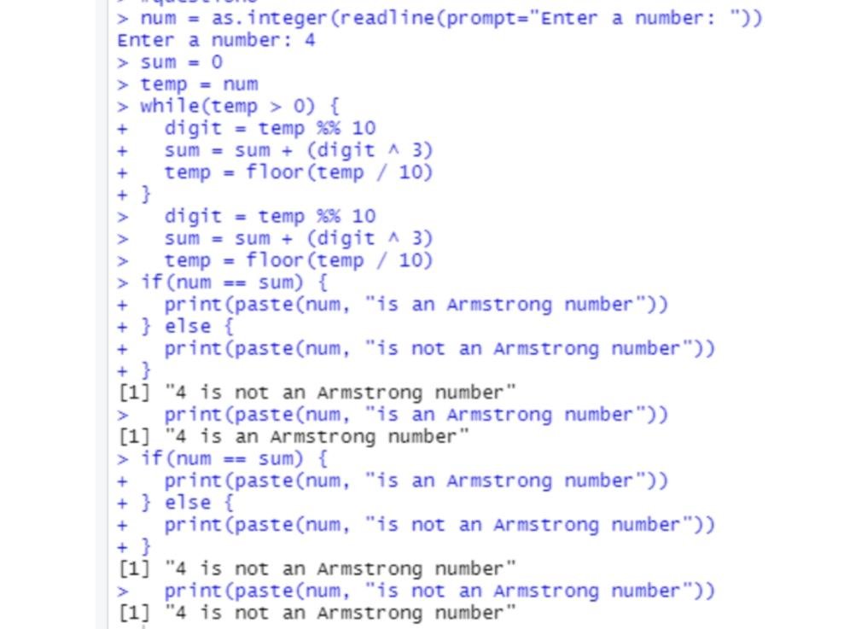

**Question 9**

n<-1

repeat {

sum = (n * (n + 1)) / 2

n<-n+1

if(sum>100) {

break

}else{

print(paste(n))

}

}

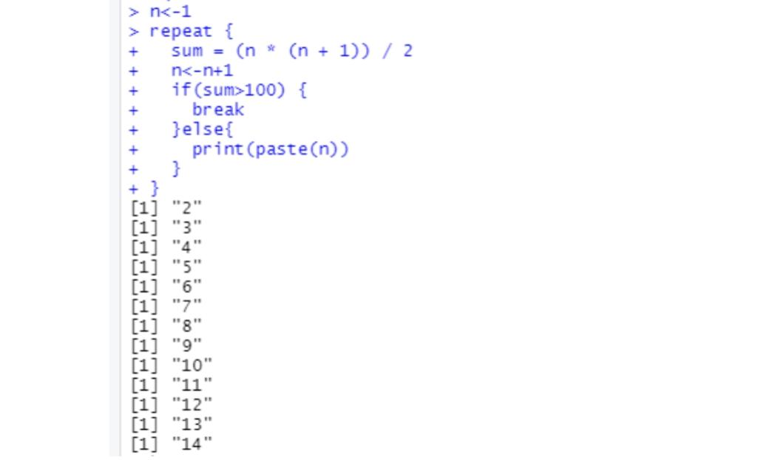

**Question 10**

#break

a<-1

while (a < 10)

{

print(a);

if(a==5)

{

break;}

a=a+1;}

#next

x<-1

while (x< 5)

{ x=x+1;

print(a) ;

if(x==3)

{next;}

print(x);}

